REQUIREMENTS FOR HBTMC & RNCH WEBSITE
Kindly provide the following information mandated by MCI to be updated on the HBTMC & RNCH official website.

Name of the Department: DEPARTMENT OF BIOCHEMISTRY Departmental Contact No: 022-26207254(Extension No.305) Departmental Email ID/ Website: biochemcooper@gmail.com

Teaching Faculty
Sr No. | Name | Designation
1 | Dr. Surekha Ramesh Prabhu | Professor and Head | 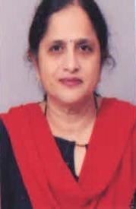
2 | Dr. Hemant Sharad Dahake | Associate Professor | 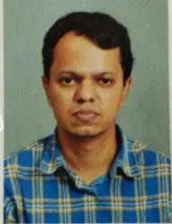
3 | Mrs. Smita Amol Deokar | Assistant Professor
4 | Dr. Alisha D’souza | Tutor
5 | Dr. Rutuj Mali | Tutor | 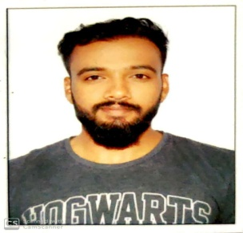

Non -Teaching Staff
Sr No. | Name |  | Designation |  | Photo (Softcopy)
1 | Mr.Rohit Patil |  | Laboratory Technician
2 | Mrs. Ulka Naram |  | Laboratory Technician |  | 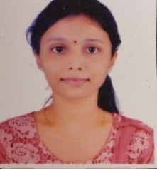
3 | Mrs. Shilpa Tare |  | Laboratory Technician |  | 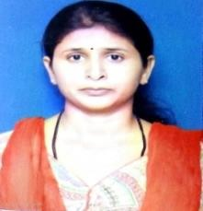
4 |  | Miss. Ashwini Gaikwad |  | Clerk

Research Publications through the department since inception

Dr. S. R. Prabhu : Professor and Head

  - Estimated GFR:/Screening Tool for Kidney Dysfunction; Int J Med Res.2016:2(4):114-16.
  - Evaluation of Anti-Retroviral Therapy in HIV Seropositive Individuals in Mumbai-A Relationship Between Viral Load & Cd4+T-Lymphocyte Count; International journal of Scientific research 2016;VOL5(7),30-32.
  - Association of HbA₁c with Kidney Dysfunction in Diabetes Mellitus and Cardiovascular
Diseases; People’s journal of Scientific research 2016;9(2):1-6.
  - Flax Seed: as an Independent Natural Agent for Lipid Profile Improvement; Indian journal of applied research, 2016;6(8);70-72.
  - Association of HbA₁c with Kidney Dysfunction in Diabetes Mellitus and Cardiovascular
Diseases; People’s journal of Scientific research 2016;9(2):1-6.
  - Flax Seed: as an Independent Natural Agent for Lipid Profile Improvement; Indian journal of applied research, 2016;6(8);70-72.

Dr Hemant Dahake: Associate Professor

Urinary Albumin Excertionrate:Diagnostic and prognostic utility in essesntial hypertension. Jounal of Pharmaceutical and Biomedical Sciences.2010,3(08).
Yogesh R Pawade, Suresh S Ghangale, I. C. Apte, Abhay Nagdeote.Hemant S Dahake,JayeshWarade

ALBUMIN-ADJUSTED CALCIUM: ARE PREVIOUSLY PUBLISHED REGRESSION EQUATIONS RELIABLE FOR YOUR LABORATORY? – A PILOT STUDY. Journal of Medical Science and Public Health | 2013 | Vol 2 | Issue 2. Pawade, Suresh S Ghangale, Hemant S Dahake.

Study of iron profile in sickle cell disease patients. International Journal of Biological & Medical Research2013; 4(3) :3271- 3274. Dr. J. P. Warade, Dr. I. C. Apte, Dr. H. S. Dahake, Dr. Y. R. Pawade.

Biochemical marker of Hepatic Injury in Sickle cell disease. International Journal of medical science and clinical invention Vol 1 Issue 5 2014 page no. 254-260.

Comparison between direct estimation of LDL and Friedewald’s formula. International archives of Integrated medicine,Vol-3,Issue-2,February 2016

Study of nonenzymatic antioxidants in schizophrenic patients. International Journal of Research in Medical Sciences Accepted 23 july 2016.

Study of Malondialdehyde as an oxidative stress marker in schizophrenia. International Journal of Research in Medical Sciences Dahake HS et al. Int J ResSci2016 Nov;4(11):4730-4734

Evaluation of quality of MBBS Biochemistry theory question papers of medical institutions in Maharashtra. International Journal of Research in Medical Sciences Dahake HS et al. Patke V et al. Int J Res Med Sci. 2017 Oct;5(10):4336-434.

Mrs. Smita A. Deokar nee Pawar: Assistant Professor

- Study of biochemical markers in iron deficiency anemia. Int J Res Med Sci [Internet]. 2013;1(4):541.
- Antioxidants deficiency: a sensitive indicator of cardiometabolic risk in chronic renal failure. International Journal of Research in Medical Sciences | October-December 2013.May ;1(2):87-92
- Study of serum sodium and potassium concentration in cataract patients. International Journal of Research in Medical Sciences | October-December 2014 May; 2(2):592-594.
- Evaluation of usefulness of serum Insulin as sensitive predictor of cardiovascular dysfunction in obese individuals with normal lipid profile.Journal of Clinical and Diagnostic Research 2014, Vol.8 (10) pp.CC10-CC12.

- C-reactive protein as an additional marker for increased risk of cardiovascular disease in patients of hypothyroidism. Int J Adv Med. 2015;2(1):13–5.
- Serum IL-1 beta and biochemical markers in myocardial infarction. Indian Journal of Applied Research. 2017 Vol.7(1) pp 842-844
- Serum zinc and copper levels: a marker of disease activity in senile cataract patients. International Journal of Research in Medical Sciences. 2017 Vol. 5(8) pp. 3697-3700.
- Smita Amol Deokar, Sucheta P. Dandekar GAS. Role of serum interleukin-6 in heart failure. Int J Adv Med. 2018;5(4):936–40.
- Quantifying Serum IL-1β Cut-Off Point for Detecting Cardiovascular Diseases in a Population from Western Maharashtra. J Clin Diagnostic Res [Internet]. 2018;12(7):21–4.
- Serum calcium and phosphorus levels: a marker of disease activity in senile cataract patients. Int J Adv Med. 2018;5(2):371–4.
- Increased serum alkaline phosphatase activity in different cardiac diseases. Int J Recent Sci Res. 2018;9, Februar(2(G)):24262–4.
- Significant Difference in the Serum Aspartate Aminotransferase Levels Across the Diagnostic Categories of Various Cardiac Diseases. Int J Dent Med Spec. 2020;7(1):26–8.
- Serum levels of IL-8 in chronic RHD. Vol. 7, SSRG International Journal of Medical Science ( SSRG-IJMS ). 2020.
- Serum tumour necrosis factor- α in myocardial infarction. Int J Med Sci Curr Res. 2020;3(4):48–51.
- Serum levels of inflammatory markers in relation to left ventricular function in cardiac patients. IOSR J Dent Med Sci e-ISSN. 2020;19(5):19–21.

- Awards and Achievements received by students and faculty since inception.
Mr.Viraj Mohite and Ms. Dipasha Agarwal (of Batch 2016-2017) won 3rd prize in state level Biochemistry quiz competition.

 | Degree/Diploma | Year | No of Students Appeared | No of  Students Passed | Passing percentage
UG | MBBS | 2017-2018 | 155 | 7 | 95.48
 | MBBS | 2018-2019 | 153 | 8 | 94.77
PG | NA | 2017-2018 | NA | NA | NA
 | NA | 2018-2019 | NA | NA | NA
- Results for examinationfor the year in the following format-

- Vision of the department :
- To increase the quality and number of investigations done in the routine and emergency laboratories.
- To provide good academic exposure to first year MBBS students.
- To conduct CMEs and conferences so as to update the knowledge of faculties and students in laboratory medicine.

- Other information:
  - Sections/Units of the department - NA
  - Services provided (new and old) – Laboratory services and teaching for Ist year MBBS students
  - Specialty-wise bed distribution
  - Departmental location – 4th floor E-wing, Hospital building
  - Time and days – 9am to 5pm, Monday to saturday
  - Patient related/ Non-academic Activities – Laboratory services

- The investigations done in Routine Central Clinical Biochemistry Laboratory
  - Parameters (serum/plasma): BSL (F, PP, R), BUN, Creatinine, Na, K, Cl, Bilirubin, Amylase, PT-INR, ABG, Total Protein, Albumin, S.G.O.T., S.G.P.T., Alkaline Phosphatase, Ca, P, Uric Acid, Cholesterol, HDL cholesterol, Triglycerides.
  - Arterial blood gas analysis: including pH, pO₂, pCO₂ & bicarbonate
  - Parameters (urine): Ca, Creatinine, Bence-Jones Proteins, 24 hrs. albumin, spot alb/creatinine
  - CSF protein & sugar
  - Peritoneal fluid for amylase
- The investigations done in Emergency Central Clinical Biochemistry Laboratory
Parameters: RBS, BUN, Creatinine, Na, K, Cl, Neonatal Bilirubin, Amylase, PT-INR, ABG,CRP.

